Kings Landing Foundation Visiting Cousins Bursary - 2019
Teacher Recommendation Form

Submit completed form to 2019visitingcousins@gmail.com
Please print:
Name of Student
Student’s Age M___ F___
Name of School
Name of Recommending Teacher
Beyond financial need, what makes you feel that this student merits a VC Bursary?

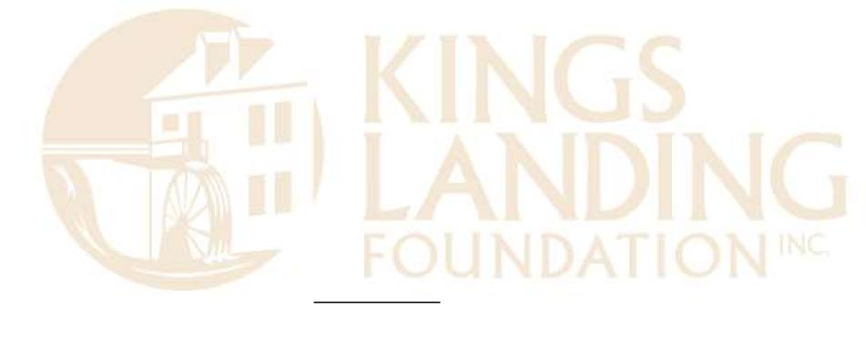
Teacher Contact Information:
Phone
Email

With the child’s parent’s/guardian’s awareness, I am recommending this student who would otherwise be unable to be a Visiting Cousin without financial assistance. If the student is chosen as a Bursary recipient or alternate I will assist the student’s family/guardian with completion of the Visiting Cousins Registration Form and I will send it to Kings Landing Historical Settlement on the family’s behalf.
Teacher Signature
Recommendations must be submitted by Friday, March 29, 2019

